IACV Homework 2021  
Nicolo’ Stagnoli - 10578583  
January 14, 2022

Introduction  
For this homework we have an image of the back side of Villa Melzi. We know that facade 1 and 5 are  
coplanar, facade 2 and 4 are perpendicular to facade 1, 3 and 5. We also have to position of the sun  
in the real world (a point at infinity in 3D); We know that the camera is 1.5 meters above the ground.  
Natural camera cannot be assumed. We know only that skew factor can be assumed to be 0.

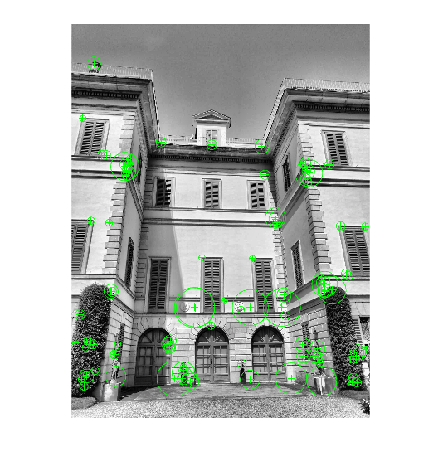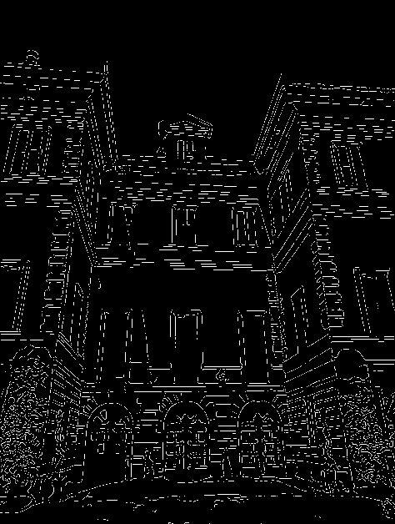  
F1 - Feature Extraction  
To extract relevant features from the image, I first applied a grayscale, taking into account all the 3  
color channels, and then histogram equalization. Then I used Canny edge detection algorithm. This  
algorithm returns a binary image composed by lines, this result simplify the application of the lines  
detection exploiting the Hough transformation. In order to detect the lines in the image I used the  
Hough transformation. Finally, I retrieved the segments lines setting a max gap between two points  
on the same line and the minimum length of a segment line of 25 pixels. For the feature extraction  
step, I used the SURF algorithm which produces the best result.

For the next steps, i saved some of the extracted lines in .mat files to reuse them subsequently.

G1 – Horizontal Plane Reconstruction

To recover the affine properties of the images we have to put back the line at infinity in the image to its canonical position [001]T. I extracted the line at infinity using vanishing points from horizontal lines of facade 2 (or 4) and of facade 3.

The projective transformation to restore affine properties is:

Applying this transformation to the image gives this result:

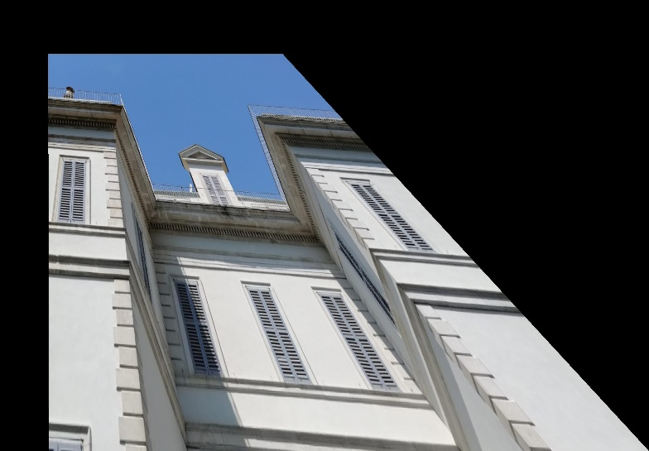

In order to recover also metric properties, i defined an affine transformation like this:

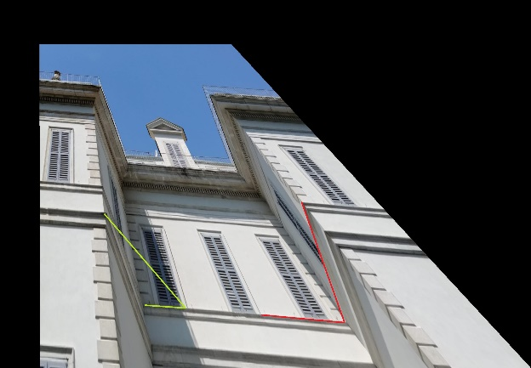where variables a and b are to be estimated. For this purpose, i used two additional informations from the image:

* 90 degree angle between facade 3 and 4
* 75.6 degree angle between the horizonal line on facade 3 and the shadow projection of the left edge on facade 3. I computed this angle using the location of the sun in the real scene. In the initial image i noticed that the shadow of the edge was aligned with the right side of the left windows on facade 3.

So, solving this system of 2 equations gives the affine transformation to recover metric properties:

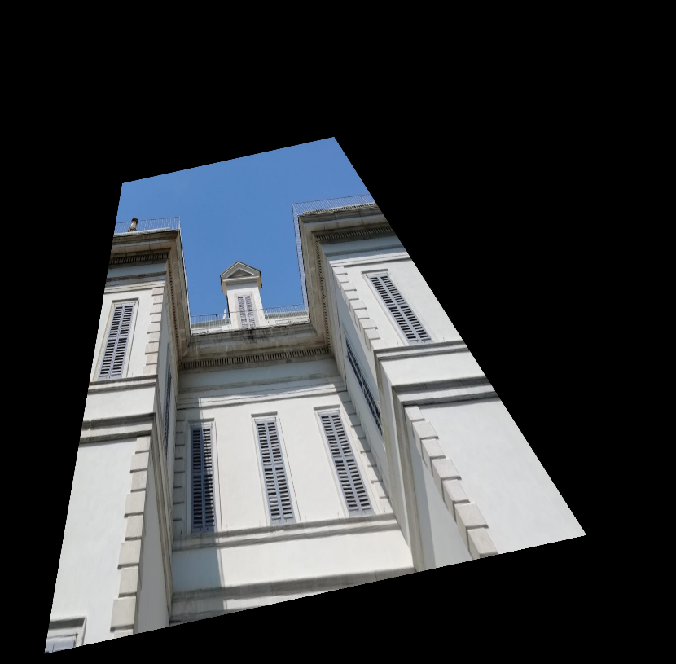

Here the result of the metric reconstruction.

The ratio between the lenght of facade 3 and facade 4 is (lenght directly measured in pixels on the rectfied image):

473 px / 663 px = 0.71

G2 – Camera Calibration

To estimate the intrinsic parameters of the camera, i set up this matrix of four unknown variables, corresponding to the image of the absolute conic. .

The calibration matrix K can then be calculated applying cholesky factorisation to the IAC matrix.

To estimate the unknown variables, i tried two similar approaches:

* I first tried the method using the vanishing points of the scene and imposing an angle of 90 degrees between their line at infinities (this gives 2 independent constraints). For the other 2 constraints i took the rectification matrix from the previous step (Hrect \* Haff), inverted it, and took the first two columns h1 and h2 of this matrix. Then i used this two equations (from the theory).

However, the result was not enough satisfying in the next steps.

* In the second approach i used the same first two equation as before, while for resolving the other 2 constraints i took some lines from the arcs above the doors on facade 3, noticing that there is a 90 degree angle between them. The results in the next steps was better than before with the IAC calculated in this way.

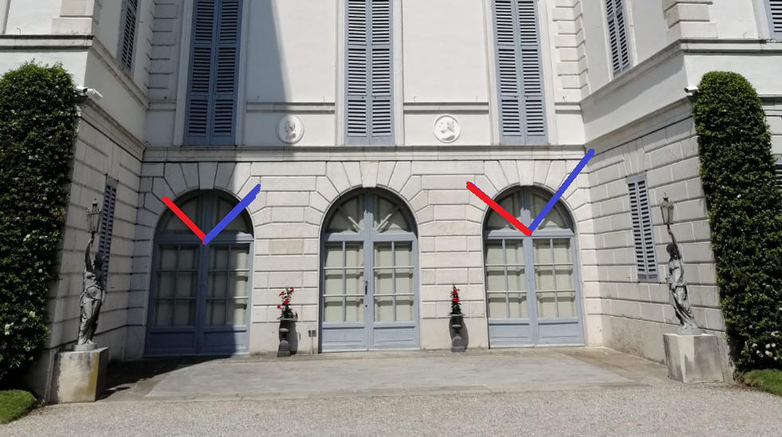

I estimated this calibration matrix K:

G3 – Vertical Facade Reconstruction using IAC

To reconstruct facade 3, i took the previously estimated Image of the Absolute Conic and found its intersections with the line at infinity extracted from the initial image. To extract this line, i used vanishing points from vertical and horizontal lines of facade 3.

So i obtained the image of the circular points I’ and J’.

I calculated and applied singular value decomposition to this matrix. From the output of svd, i extracted the rectifying homography Hrect2.

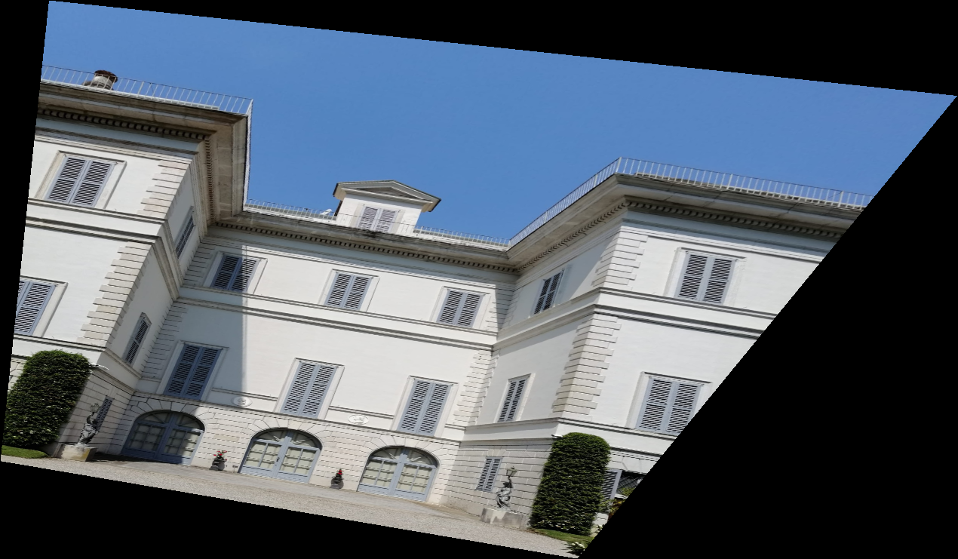Here is the result:

G4 – Camera Localization

To localize the camera in the 3D scene, i used the matlab function fitgeotrans(…), taking the four points as the corners of facade 3 from the initial image.

Then, imposing the height of the camera from to gound to 1.5 meters, I estimated the camera position as:

x = 3.6249 m

y = 1.5000 m

z = 23.1578 m (distance from facade 3)

Camera orientation :

x-axis: 25.3101°

y-axis: 5.6561°

z-axis: 1.4751°

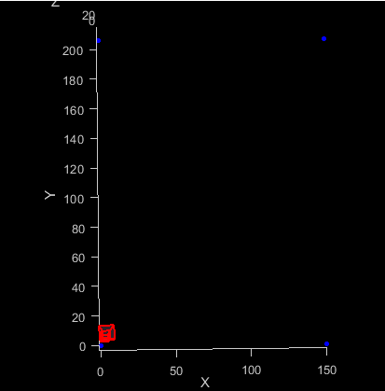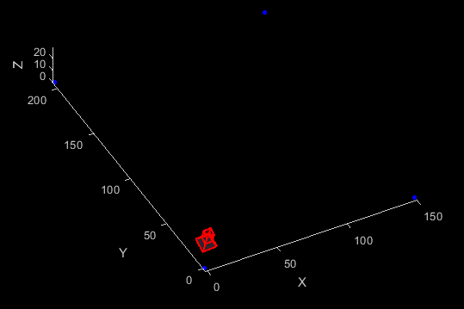In the images below, the blue points are the corners of facade 3.